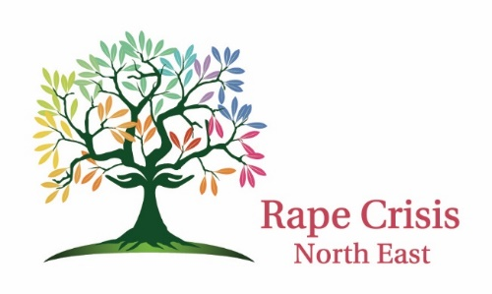

Rape Crisis North East Clg (RCNE) in collaboration with Meath Women’s Refuge & Support Services are recruiting A Fully Accredited Part-time Counsellor/Psychotherapist.
Rape Crisis North East in collaboration with Meath Women’s Refuge & Support Services are recruiting one part-time counsellor (22.5 hours) to work in their new established office in Navan for 2 days per week and one day in Dundalk supporting adults and young people (aged 14 upwards) who have experienced any form of sexual violence at any time in their lives.

Due to the high volume of clients in need of our services we are actively looking for dynamic and highly motivated individual to join our team.

We are committed to delivering our services with care and professionalism and continue to strive to ensure that we provide the best service for all our clients.

The ideal candidate will:
- Be a fully qualified & accredited member of IACP, IAHIP, PSI, ICP.
- Have experience and/or training in working with sexual violence.
- Have experience in working with adolescent and adult clients.
- Have experience / knowledge of the domestic violence sector.
- Demonstrate excellent, written, listening and verbal communication skills.
- Have IT skills and experience in report writing.
- Demonstrate great warmth and empathy.
- Liaise with other professionals and organizations as appropriate.
- Work as part of the Clinical Team.
- Report to the Manager of RCNE.

The successful candidate shall be required to:
- Work within the ethos and philosophy of RCNE.
- Provide face to face counselling to survivors of sexual violence.
- Liaise with clients and their families as appropriate with regard to assessments, outcomes, interventions and reviews.
- Receive ongoing supervision.
- Actively participate in RCNE internal meetings e.g. staff meetings, clinical meetings as appropriate.
- Complete the Specialised Rape Crisis Sexual Violence Training.
- Take responsibility for one’s own continued professional development.
- Keep up to date with best practice and procedures in line with the Code of Ethics of IACP, IAHIP, PSI or equivalent professional bodies.
- Flexibility is required as you may be asked to work outside of opening hours.

Salary for this post is based on the current HSE Social Worker Salary Scale pro rata.
Other benefits:
- RCNE offer allowances towards CPD training to all counselling positions.
- Clinical Supervision will be paid by Rape Crisis North East Clg.
- Access to the Employee Assistance Programme
- RCNE is an equal opportunities employer.

Note: the successful candidate will be required to complete a Garda Vetting application form.

Please email a cover letter and curriculum vitae to info@rcne.ie. Candidates will be interviewed on a rolling basis.

