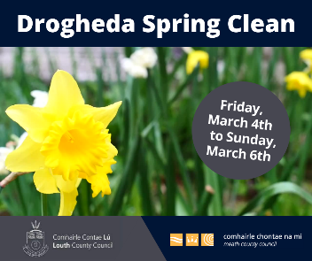
Drogheda Spring Clean
Participation Form
Louth and Meath County Council are fully aware that there are many groups and individuals around the greater Drogheda area who would like to contribute to their local community by taking part in enhancement works in their local area.
With this in mind a Drogheda Spring Clean event is planned which will take place from Friday 4th March to Sunday 6th March. All interested groups (residents associations, community groups, sporting organisations, schools, colleges, active age, mens sheds etc) and individuals are invited to take part.
If you would like to be involved, please fill in the details below and return your form to community@louthcoco.ie or environment@meathcoco.ie
When we receive your form, we will issue an email which you can bring to the V and W (Drogheda) Recycling Centre, Mell, Drogheda to collect your Clean Up pack.
You can then plan your clean up in your local area over the weekend beginning 4th March. When you have finished your clean up please send an email to either of the above and your waste will be collected. Include in the email your name, contact number and the exact location of the bags to be picked up.
Tree Week will take place later in March and to mark the event all participants in the Drogheda Spring Clean can avail of free native saplings which can be used to further Green your local area. You will receive an email when they are ready for collection.
Most importantly the scheme is an opportunity for you or your community to work together on a project which benefits everybody.
The following are examples of the work/activities that can be included:
- Removing litter
- Planting appropriate native trees and shrubs
- Report illegal dumping
- Cleaning and maintaining signs

Useful Resources
To report illegal dumping where there is potential evidence (in the dumped waste or a vehicle registration or other identifier), email environment@meathcoco.ie or denise.meegan@louthcoco.ie
To get pickers, bags and gloves for clean-ups Email: environment@meathcoco.ie community@louthcoco.ie
Identify native wildflowers: www.wildflowersofireland.net
Find out about the National Pollinator Plan www.pollinators.ie
Identify invasive species such as Japanese knotweed: www.invasivespeciesireland.com
Learn about hedge laying (traditional hedge cutting techniques): www.hedgelaying.ie
How do I get involved?
Send us your completed participation form to the email addresses below:

Name of individual/group: ___________________________________________________

Contact name: ___________________________________________________

Contact Tel: ___________________________________________________

Contact email: ___________________________________________________

Address/location of Clean Up: _____________________________________________
Include map, (If possible), Townland, Eircode etc. to assist in locating your chosen area

Please send Queries and/or Completed Forms to:
community@louthcoco.ie Or Drop into post box or call into Customer services in Drogheda Borough Council, Fair Street, Drogheda, with your completed form.
Or post to Green KM Scheme, Community Section, Louth County Council, Millennium Centre, St Alphonsus Road Dundalk Co Louth
environment@meathcoco.ie or by post to Meath County Council, Buvinda House, Dublin Rd, Navan

