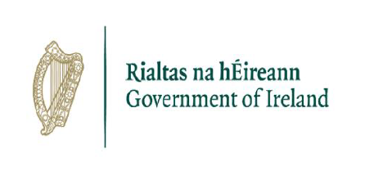

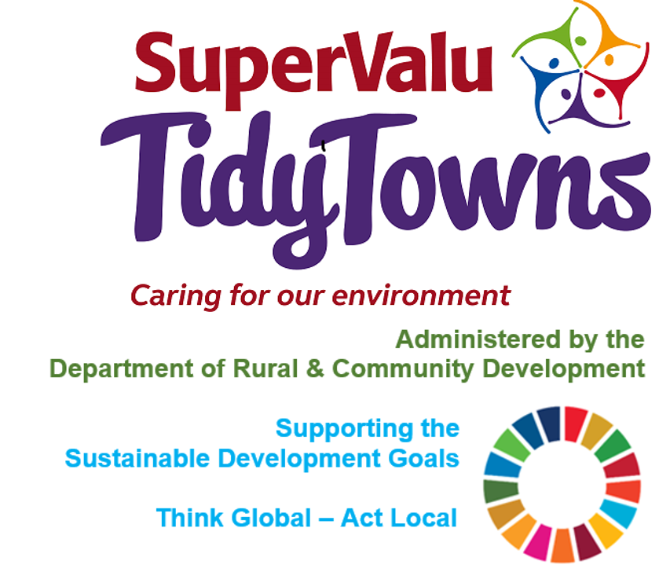

**StudentVolunteer**

An easy to use, one-stop-shop portal connecting higher education students with civil society organisation volunteering opportunities.

[StudentVolunteer.ie](http://StudentVolunteer.ie)

**Bray TidyTowns**

<https://www.facebook.com/Braysbarbie-115258420225675/?__tn__=%2Cd%2CP-R&eid=ARBMSneAMhWxydN8D2VX02URnSX1h7sT0rKtyjAQG1YQIrkXI3mhVV4qyIt_8yxfHP_U7CwkaOtKCtHK>

This is a video of some fun at Peoples Park

<https://www.facebook.com/BrayTidyTowns/videos/1273530316324887/?t=1>

This video was shown during National Volunteer Week

<https://www.rte.ie/learn/2020/0923/1166933-bray-tidy-towns/?fbclid=IwAR3tLUhpeI8TYenF5B0CxdQvZXdi9XnGJwJjTCUNHvTM75lGNKXb-mpBTjo>

**Stay Healthy this Christmas**

<https://www.gov.ie/en/campaigns/healthy-ireland/>

<https://stopfoodwaste.ie/>

<https://stopfoodwaste.ie/resources/planning-shopping>

<https://stopfoodwaste.ie/resources/communities/tidy-towns-community-resources>

<https://stopfoodwaste.ie/?s=christmas>

<https://www.safefood.net/>

**Unwanted Gifts & Packaging**

[www.repak.ie](http://www.repak.ie)

**Birdwatch Ireland**

<https://birdwatchireland.ie/>

<https://birdwatchireland.ie/irelands-birds-birdwatch-ireland/garden-birds/>

<https://birdwatchireland.ie/our-work/surveys-research/research-surveys/irish-garden-bird-survey/>

 <https://www.facebook.com/OfficialSuperValuTidyTowns>



[Description: Description: Description: https://encrypted-tbn2.gstatic.com/images?q=tbn:ANd9GcTn6e_yvEEKZGqngkOvFQKXiE5grEl9MBv8f3BIJGAnDVia4IA6BMWDw64](https://www.google.ie/url?q=https://about.twitter.com/press/brand-assets&sa=U&ei=gIVOU7azCeed7Qafq4DoCw&ved=0CC4Q9QEwAQ&sig2=_2Ys344bv7jS9rXT1Izm4w&usg=AFQjCNEMyI7-tFvyJYa1KkCdXm5XILcS9g)   <https://twitter.com/TidyTownsIre>



<https://www.tidytowns.ie>