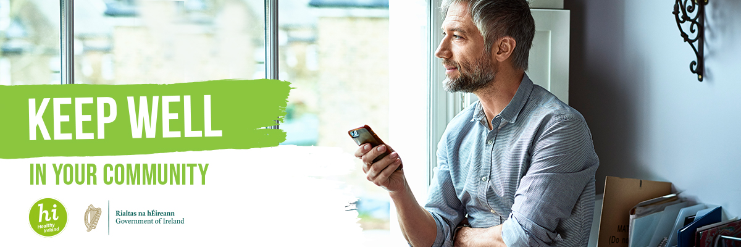

Keep Well Government Resilience Campaign

CAMPAIGN RATIONALE
The Government Plan for Living with COVID-19: Resilience and Recovery 2020-2021 highlights the important role that individual and community resilience will play in contributing to our ongoing response to COVID-19.

This campaign is aimed at showing people of all ages how we can mind our own physical and mental health and wellbeing by adding healthy and helpful habits to our daily and weekly routines. It will provide guidelines, information, and tips on how we can make a plan to do things that are good for us everyday. The campaign website will be hosted on gov.ie/healthyireland and will signpost to information about local resources and initiatives that will be available through the Local Authorities.

The campaign also includes an allocation of funding from Sláintecare to support a number of initiatives through the Healthy Ireland Fund that will be rolled out over the coming months.

CAMPAIGN MESSAGES
This will be one of the most difficult winters that we’ve faced in a long time. Nothing has ever felt so abnormal in living memory. We’re not going to attempt to dismiss that or force an outlook on people. But we want to be upbeat. We will acknowledge that ‘this’ isn’t normal before pointing to things we can all do ‘everyday’ to make it a bit easier. We will encourage people to make a weekly plan to do these things. Things like:

- Keeping active and being outdoors - even during the winter, it is important to help physical and mental health and wellbeing.
- Staying connected - staying connected with people and addressing isolation as person-to-person connection is important to our wellbeing.
- Switching off and being creative - switching off and being creative or learning something new, getting back to nature and finding ways to relax can help our general wellbeing.
- Eating well - by nourishing your body and mind we can positively impact our physical and mental wellbeing.
- Managing your mood – equipping people with information on where to go if they need support e.g. HSE’s Your Mental Health website.
MULTIMEDIA
The campaign is a multimedia campaign which will run for the next five months across National TV, National and local radio, video on-demand, digital platforms, social channels and is supported by media. It will sign post people the Government Departments and relevant agencies who have an offering in this wellbeing space.

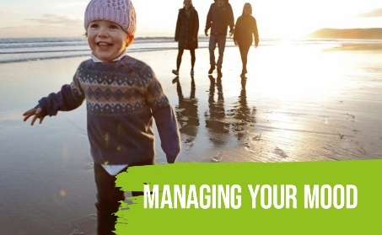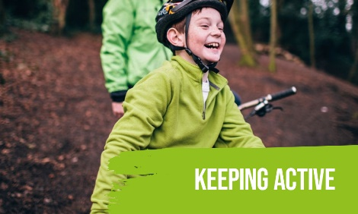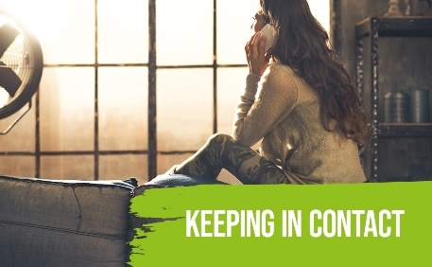

NEW WINTER INITIATIVES
New initiatives will be rolled out under the “Keep Well” campaign over the coming months. Initiatives that are currently being developed and implemented include:

- Keeping active - Sport Ireland is leading a series of initiatives that will support people to stay active in their own local areas throughout the winter. Sporting organisations and clubs will be developing ways to support local communities.

- Staying connected - Building on the Community Call response earlier in the year, Local Authorities will be providing a local community helpline and befriending service.

- Switching off and being creative - The Local Authorities and libraries in partnership with Creative Ireland, and working with partners at national and local level, will provide a range of initiatives to support individual and community creativity in the arts, crafting, culture and heritage.

- Eating well - safefood will implement the next phase of their “START” campaign, focusing on making the most of family time and adding healthy habits. Bord Bia will provide information and resources to support healthy eating this winter. In addition, the network of libraries around the country will facilitate a major initiative in early 2021, to support more people to grow their own food.

- Minding your mood – The HSE will launch a series of “Minding Your Wellbeing” resources in the coming days. In addition, the Children and Young Peoples’ Services Committees (CYPSC) around the country are being supported to provide relevant activities and supports to children, young people and families over the coming months.

CAMPAIGN PARTNERS
Your local response to this campaign is a really welcome addition and adapting your content to fit the campaign will help us all push out further the local initiatives and resources which you have developed to help people cope at this time.
We will make the campaign creative materials (web/radio/video/digital/social) available to you so that you can badge your work streams with the ‘Keep Well’ creative.

We encourage the generation of ideas that could be implemented nationally or locally and to align any relevant initiatives, already underway or in development, under “Keep Well – in Your community”.
Please do not hesitate to get in touch with ideas.
#Keepwell
