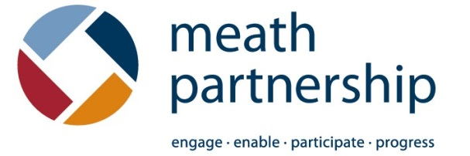

Training Application Form

Full name:
Organisation:
Phone Number:
Email Address:

I am applying for the workshop:
Recruiting Board & Committee Members
Communicating the Cause
Complying with the Charities Governance Code

Signature:

*Please fill out the application form and return it to Meath Partnership, Kells Industrial Park, Kells, Co. Meath or natasha.bagnall@meathpartnership.ie along with a refundable commitment fee of €10
