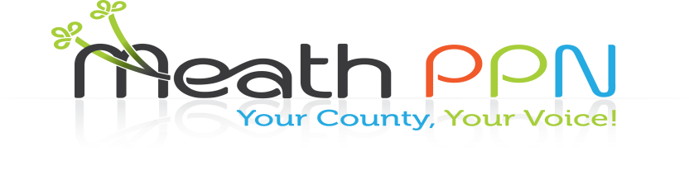

Update from the Secretariat

**Welcome to the first edition of the Meath Public Participation Network (PPN) Newsletter. We will be circulating information to you through this newsletter and invite your group to share any news items or events with the PPN members. There are currently 444 groups registered with the PPN in Meath and we are hoping to increase this membership in 2017.**

Following on from the Plenary in May at which there were a number of key issues identified and through the referral log, the Secretariat members have been focusing on the following:

**Litter/Waste in Meath:** REDC have been contracted by the Secretariat to carry out a survey in County Meath on the litter and waste problems that people are experiencing. Contact will be made with all PPN members in the New Year to complete this survey.

**Information on grants:** Information on grant schemes will be circulated to all PPN members regularly in the New Year through membership of the Wheel/Funding Point.

**Communication of information:** The Secretariat will continue to send out correspondence to members and they will have regular news items in the Meath Chronicle to update people on what is happening in Meath PPN.

News, events and updates will be posted on the website www.meathppn.ie throughout 2017.

We will be changing over to a new database in the New Year and re-registering groups so please note that you may receive a welcome email from Meath PPN.

**Health and Safety:** The Secretariat have purchased a number of Defibrillators and related training. Correspondence will be circulated in the New Year informing groups on the criteria for the allocation process for the Defibrillators.

**Homelessness in Meath:** A guide on services available has been developed and it is being updated for circulation and it will be available on our website in the New Year.

Committee Representatives

Throughout 2016 there have been a number of committee elections. The following list outlines all the PPN representatives on the various committees. In the New Year we will be strengthening the links that the representatives have with the wider PPN membership through furthering the development of the linkage groups. Members of your group who have a particular interest in one of the SPC’s or JPC below can make contact with the PPN Resource Worker, Catherina O’Rourke to become part of a linkage group for that particular committee.

|  |  |  |
| --- | --- | --- |
| Committee | Name | College |
| Planning Economic Development Enterprise SPC | Kieran Cummins | Environment |
|  | Alan Watson | Community/Voluntary |
| Environment SPC | Karen Mahon | Environment |
|  | Tom Rogers | Community/Voluntary |
| Transportation SPC | Suzanne Brady | Environment |
|  | Ben Bailey | Community/Voluntary |
| Housing Community Cultural Development SPC | Cathy Whelan | Social Inclusion |
|  | Vicky Harris | Social Inclusion |
|  | Niamh Bn Ui Loinsigh | Community/Voluntary |
|  | Liam Carey | Community/Voluntary |
| LCDC | Eamon Cassells | Community/Voluntary |
|  | John Higgins | Community/Voluntary |
|  | Sheila Comiskey | Social Inclusion |
|  | Sinead Smith | Social Inclusion |
|  | Suzanne Brady | Environment |
| Joint Policing Committee | Angela Murphy | Community/Voluntary |
|  | Carol O'Flaherty  Tracey Mc Elhenny | Community/Voluntary |
|  | Thomas Fitzpatrick | Community/Voluntary |
|  | Bernard Kenny | Community/Voluntary |
|  | Conor O’Leary  Muintir na Tire | Community/Voluntary |
|  | Jessica Bennett/Eboni Burke  Comhairle na nOg | Community/Voluntary |
|  | Jim Matthews  Laterlife | Community/Voluntary |
| Secretariat | Michael Gunn | Environment |
|  | Karen Mahon | Environment |
|  | Vicky Harris | Social Inclusion |
|  | Tracey Holsgrove | Social Inclusion |
|  | Keith Mulvey | Kells MD |
|  | Gareth O’Brien | Community |
|  | Ronan Murtagh | Community |
|  | William Brennan | Ashbourne MD |
|  | Pat Wigglesworth | Trim MD |
|  | Patricia Lynch | Rathoath MD |
|  | Teresa Stack | Laytown/Bettystown MD |
|  | Bernard Kenny | Navan MD |
| Leader Independent Evaluation Committee | James Cooke | Community/Voluntary |
|  | Mary Lydon | Social Inclusion |
|  | Kieran Cummins | Environment |

Environment College update

The Meath Environmental Network is composed of representatives of groups that comply with the criteria of the Irish Environmental Network for membership. The primary object of the group is the promotion, preservation, sustainability etc. of the natural environment.

The Network meets approximately every month to consider topics related to the environment in the county. Issue related to recycling, waste disposal, preservation of flora and fauna etc. are discussed at meetings. Guest speakers have addressed the Network in order to provide in-depth information in relation to a topic of interest to the network.

Currently a document outlining a renewable energy policy for county Meath is being finalised by the group.

Christmas Greetings

The Secretariat wish all PPN members a very happy and peaceful Christmas and look forward to continuing to work on behalf of the PPN members in 2017.