Meath Youth Arts Group
Tuesday December 6th
6.30pm – 9pm (meeting every 3 weeks!)
Navan Youth Cafe (St. Mary’s church grounds)
Visual Arts Puppetry
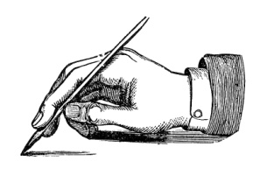Creative Writing Drama
Song Writing Music
- Open to all young people. No experience necessary.
- €20 annual fee to cover insurance
- Contact 0878543424 or meathyouthartsgroup@gmail.com for more info
